Code:Code:
Client :
Practical 6
Task 1

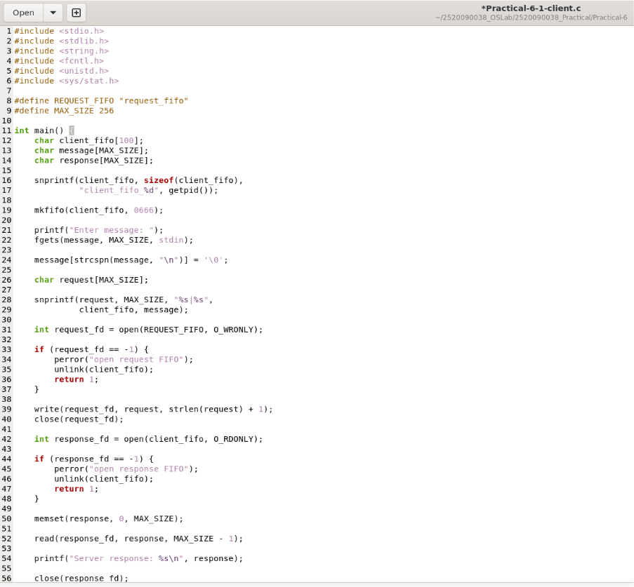

Code:
Server :
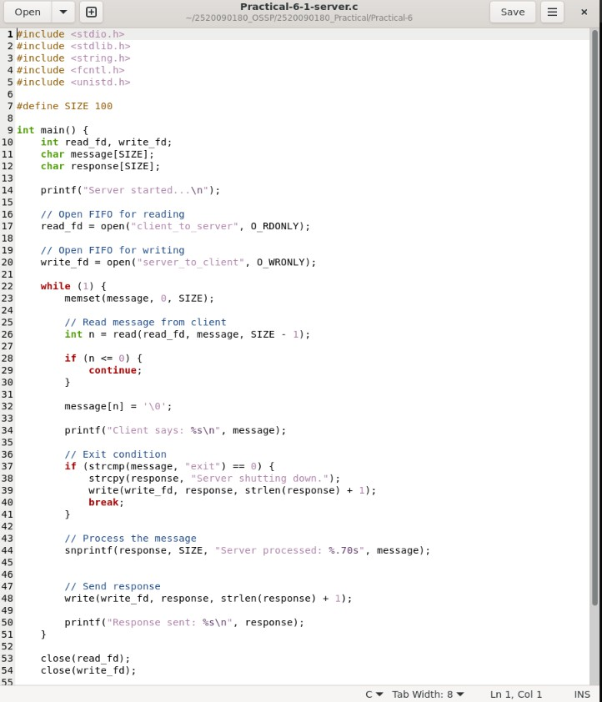

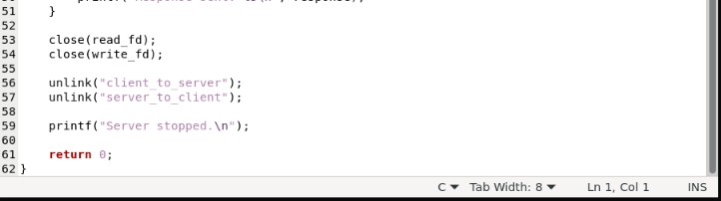

Compile and Run :

Output:
Client

Server :

Task 2
Code:

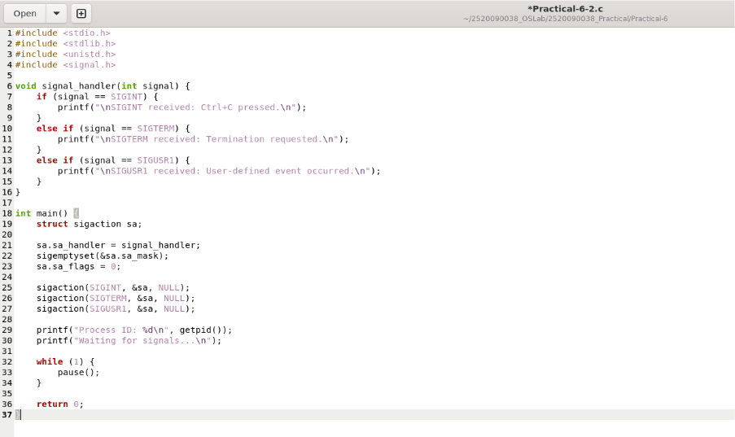
Compile and Run :
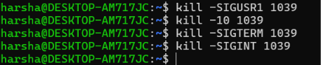

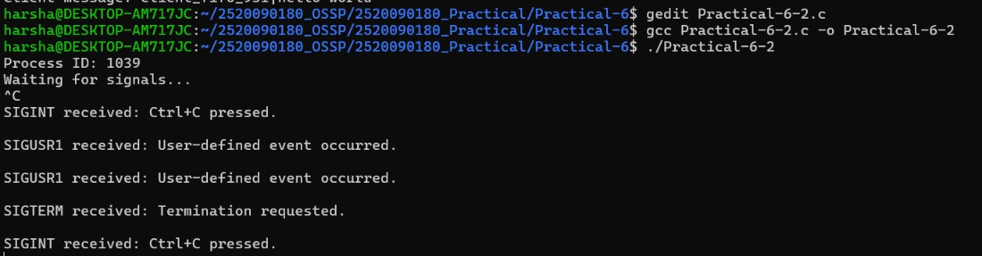
Output:

